1. In the tool name the types of reports generated in JIRA

JIRA offer reports that show statistics for projects, versions, people or other fields within issues. Various reports included with JIRA are

Average Age Report

Pie Chart Report

Resolution Time Report

Recently Created Issues Report

Resolved vs. Created Issues Report

Single Level Group by Report

Time Tracking Report

User Workload Report

Workload Pie Chart Report, etc.

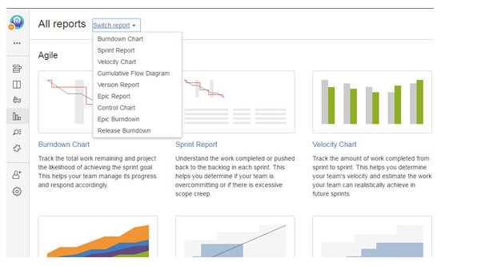

2 . Demonstrate the steps t**o create an issue in** Atlassian JIRA.

Whenever an issue or defect is encountered while testing, it needs to be reported so that the developers can work on it and take the necessary action to fix it.

We will see step by step as how an issue is created in Atlassian JIRA.

a) Log in to your JIRA account by using valid credentials and get directed to the dashboard.

b) Click on ‘Create’ button displayed and you will be navigated to a window for creating an issue.

c) Enter all the necessary details as required to create an issue. The below field example can be understood better by the image below.

* In the *Project*field*, a*project for which we are creating an issue is selected. In this example: STH_Learning(STHL) is selected from the dropdown containing all the available projects.
* In the *Issue type* field, the nature of the issue is selected from the dropdown which contains options like Bug, Task, Improvement, Story, New Feature, etc. In this example, ‘Bug’ is the nature of the issue.
* The*Summary* field contains the one line title of the issue which imparts the critical information about the issue in a summarized way. The more effective the issue headline, the more you can show the criticality of the issue. Of course, the headline should be easily understood without any chances of misinterpretation. The example I have taken here, however, is not much critical.
* The *Reporter* is the one who reports the issue. In most of the cases, the name of the Project Manager is selected in this field.
* In *Description*field, the detailed description of the issue is written. As you can see in the below example screenshot, Steps to reproduce the issue, Actual result, Expected result are included in the description.
* In the *Affect Version*field*,*the current build version of the project is selected in which the issue has been encountered.
* *Fix version* field is basically selected by the concerned developer people, who choose the version as and when their work for the particular issue has been finished and the issue has been fixed.
* *Priority* field defines which issue should be considered first to be fixed. Tester selects the priority of the issue from the dropdown based on its effect on the application. This example issue is basically of a Medium priority.
* In the *Attachment* field, any video or screenshot related to the issue is being uploaded.
* In*Environment* field, operating system and browser details are mentioned on which issue has been encountered.

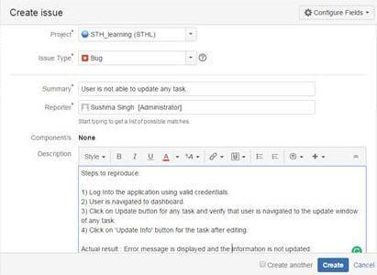

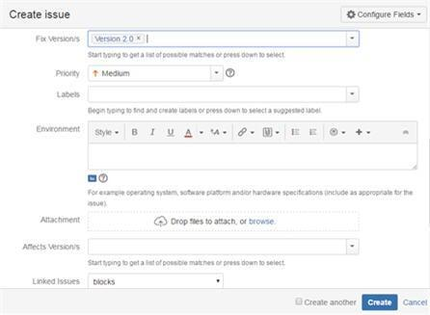

d) After all the details have been completed, click on the ‘Create’ button displayed on the window to create the new issue.

e) The issue id is generated which can be used in the future as a reference for tracking the progress of the issue.

3. Demonstrate the three color indicators denoting the amount of time spent on any particular issue in the tool.

For any particular issue in JIRA, 3 colors like Blue, Green, and Orange is used to denote the amount of time spent on any particular issue. This information is displayed under ‘Time Tracking’ section. Each color has its own significance like;

* ***Blue:*** This color is to denote the ‘Original Estimate’ i.e. the time estimate to be invested in resolving the issue. This field has been labeled as ‘Estimated’.
* ***Orange:*** This color determines the time left for resolving the issue. This field has been labeled as ‘Remaining’.
* ***Green:*** This color defines the actual time that has been used or say spent in resolving the issue so far. This field has been labeled as ‘logged’.

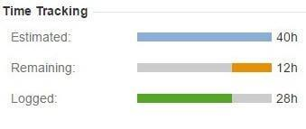

4.Demonstrate the steps for any particular issue, what all are included under change history?

Change history section displays the activities of changing any records with information regarding the person who has made the change as well as the time at which the changes have been made.

The change history also displays information about the old and new field values in the case of the change in any field.

Change history includes the following records of the changes:

* Creation and deletion of a comment.
* Creation and deletion of an issue link.
* Deletion of a Worklog.
* File attachment changes
* Issue field changes

Change history for any issue can be viewed in JIRA by following steps:

* Open any particular issue.
* Click on the ‘History’ tab present in the ‘Activity’ section.

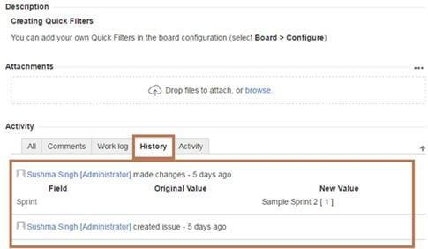

5.  Demonstrate the steps for an issue can be shared with other users in JIRA.

An issue can be shared with other users in JIRA by using the share option available on the issue description page.

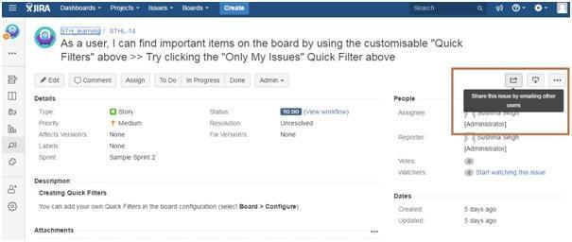

When share option for any particular issue is clicked, it contains the link to the issue to be shared along with ‘Username or Email’ and ‘Note’ field that has to be filled.

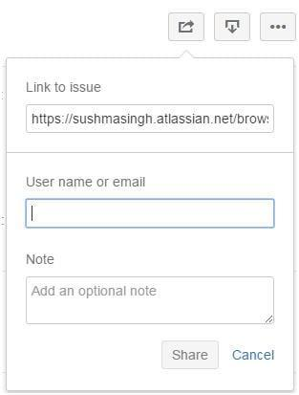

6. Demonstrate the steps labeling issue in Jira tool

 Labeling an issue is basically done to categorize an issue within a particular section which in turn can be easily searched with the help of labels.

Label for a particular issue can be initially set at the time of creating the issue, while it can edit also within the issue. Label field is displayed under the ‘Details’ section as shown below in the figure:

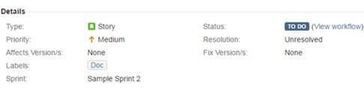

7. Demonstrate the steps **for** an issue to be linked in JIRA tool.

Linking means the association between the two.

In the same way, in JIRA issue is linked with any other issue in cases like:

* Relate to another issue
* Duplicate to another issue
* Block another issue.

For displaying the details of the Linked issues, there are two fields available in JIRA: ‘Linked issues’ and ‘Issues’.

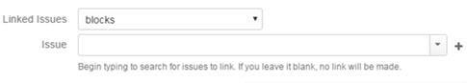

Linked issue section contains the dropdown for the options to be selected as the reason for linking the issue. As per the selected option, the suggestion of the issues to be linked in displayed in ‘Issue’ dropdown.

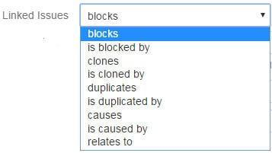

Linking of issues can be done either on the same or different JIRA servers.

8.  Demonstrate the steps to create the JIRA dashboard.

The first page which is displayed whenever we get logged in to JIRA application is ‘Dashboard’ which is basically the default or system dashboard.

A personal dashboard can also be created and designed by adding different gadgets and can be edited also as and when required. These gadgets are the means to display the project progress in terms of issues, etc.

**Steps**

**a)** Enter valid credentials and get navigated to JIRA dashboard.  
**b)** Click on “…” displayed on the upper right-hand side and choose option ‘Create dashboard’. You can also choose ‘Copy dashboard’ in the case of copying the currently viewed dashboard.

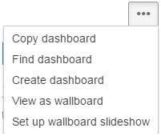

**c)** ‘Create Dashboard’ page is displayed.  
**d)** Enter all mandatory information and click on ‘Create’ button.

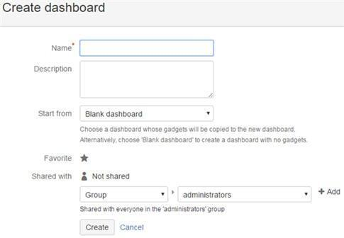

**e)** After creating a dashboard, you get navigated to a page where there are multiple options to select and add gadgets to your dashboard.

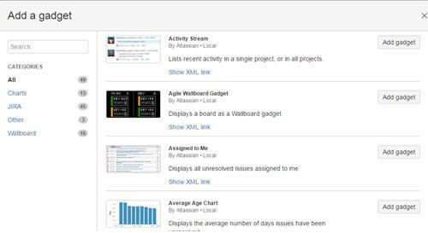

**f)** There is also an option available to choose and edit the layout of your dashboard.

Any particular Dashboard can be edited, copied, shared, delete from the Manage Dashboard section.

9.Demonstrate the steps for particular project details to be listed in JIRA.

 Every project has some main attributes which have to be displayed in the project summary. Go to ISSSUE

**This attributes include:**

* Name of the project
* Key
* Components
* Versions (if present)

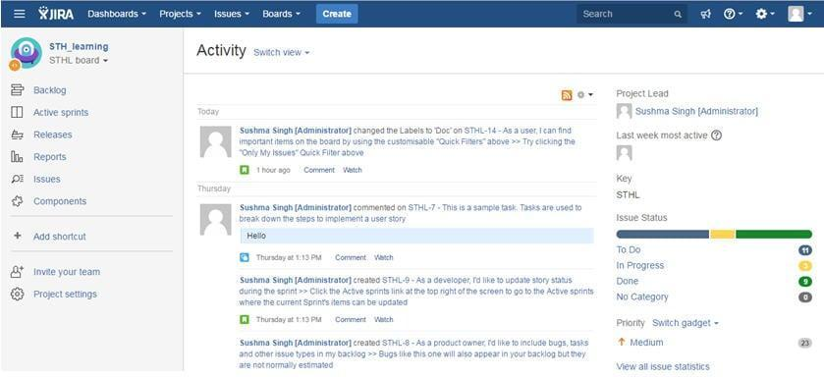

As you can see from the image, the middle display area of the page shows the ‘Activity’ screen containing details on the activities done on issues or project.

The right-hand side section displays the basic information about the Project like Project Lead, Key, Issue Status, etc.

The left-hand side contains various options like Components, issues, Reports, Active Sprints, etc. The related information is displayed as per the selection from the option.

**For Example:** If I select the ‘Issue’ option, the below-displayed screen will appear.

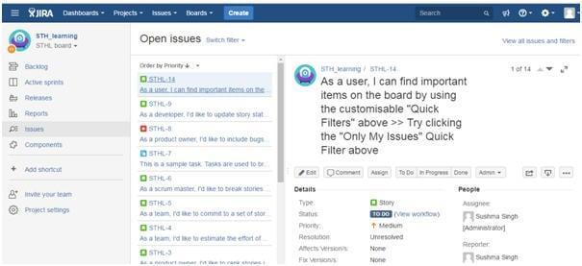

10. Demonstrate the steps for various issues types created and tracked via JIRA tool.

JIRA has some defined set of default issue types which are displayed under ‘Issue Type’ section.

Other issue types can be added, edited and deleted as per requirement of the project. Some of the common issue types are Bug, Task, Sub-task, Epic, Story, etc.

Their details can also be seen under Issue type section as shown in the below figure.

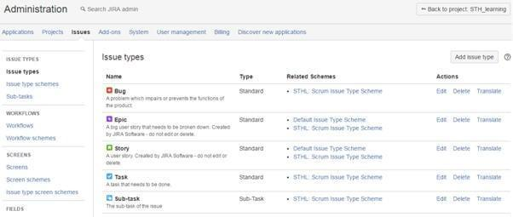

As the definition of ‘***Issue Type Schema’*** mentioned in JIRA application,

An issue type scheme determines which issue types will be available to a set of projects. It also allows specifying the order in which the issue types are presented in the user interface.

**There are two types of Issue type Schema:**

* Default Issue type schema
* Scrum Issue type schema

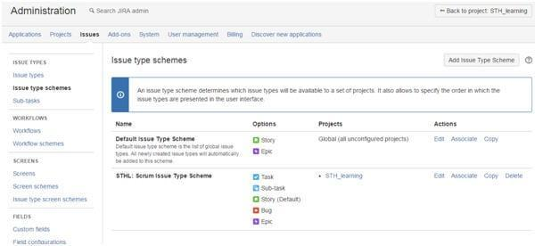

11. Demonstrate the steps for a sub-task to be created in JIRA?

 Sub-task is the way of splitting up of parent issue into a number of small tasks which are tracked and worked on separately.

The parent issue contains the information of all its sub-tasks which can be only of the same project. A parent issue cannot be closed unless and until all its sub-tasks are closed. A sub-task has the same fields as that of any standard-issue but their issue types are different.

Now, let us see step by step how a sub-task is created. I have created an issue in the below example for the understanding creation of the sub-task.

a) Open a parent issue by searching with an issue id or create any new issue id.  
b) On the right-hand side of the issue description screen, you will see “…”. Click on it and options are displayed.  
c) Click on Create Sub-task from the displayed dropdown option.

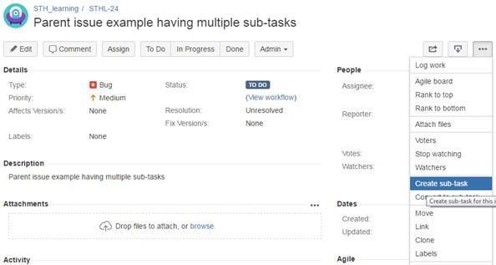

**d)** Create a sub-task window is displayed.  
**e)** Enter all the mandatory details and click on the ‘Create’ button.

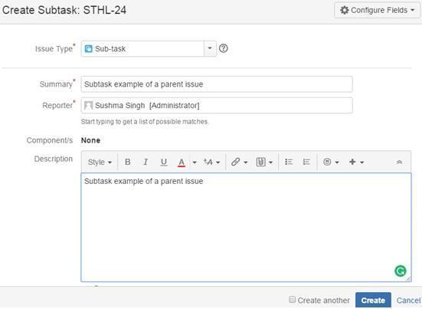

**f)** Now the created sub-task gets added to the parent issue under sub-task section as shown below in the figure:

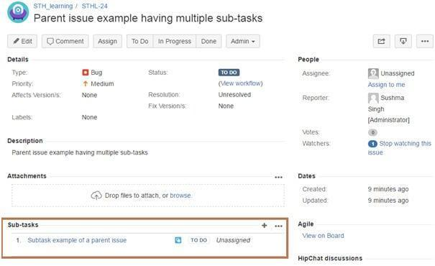

**g)** There are also options available to convert an issue into a sub-task as well as sub-task into an issue.

**Session 5:**

1.Demonstrate the steps **for Cloning an issue in Jira tool.**

Cloning an issue means copying an issue.

In this condition, a clone of the original issue is created which consist of same information as is present for the original issue. Cloning of the issue is done so that multiple users can work on the same issue, however, the operation done either on the original issue or clone issue has no effect on each other.

All the information of the original issue are cloned expect few as mentioned below:

* Time tracking
* Comments’
* Issue history
* Status and Resolution

Let us see how to create a clone of an issue:

a) Open any issue by searching with an issue id or create any new issue id.  
b) On the right-hand side of the issue description screen, you will see “…”. Click on it and options are displayed.  
c) Click on Clone from the displayed dropdown option.

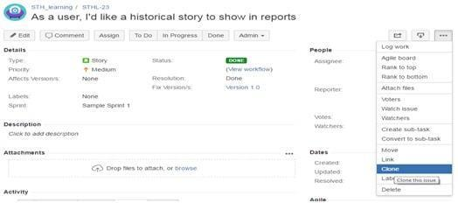

d) Clone Issue window is displayed.  
e) If required, you can edit the summary of the issue and click on the ‘Create’ button.

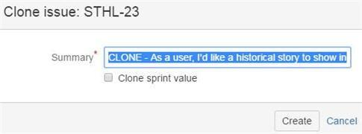

f) Another issue is created with ‘CLONE’ added in the summary.

2.  Demonstrate the steps to create Kanban boards in Jira tool.

**Let us see how the Kanban board is created in JIRA step by step.**

**a)** Log In to the JIRA application using valid credentials and get navigated to the dashboard.  
**b)** Click on Project dropdown and select the option ‘Create Project’.  
**c)** Select ‘Kanban Software development’ and click on the Next button.

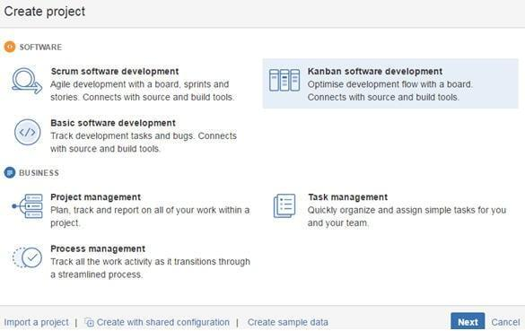

**d)** Enter all the necessary details and click on the Create button.  
**e)** Kanban board is created as shown in the below example.

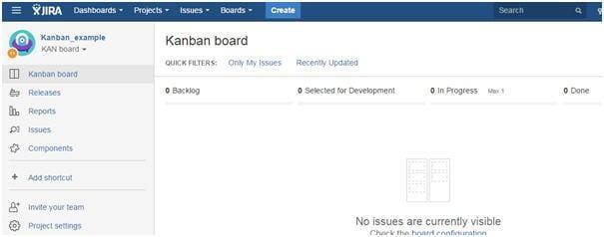

In the case of Kanban, the incoming task is given more priority and hence it is considered as the best methodology for cases like bug fixing and maintenance release.

##### **3**.Demonstrate the steps **to define JIRA Component in the tool**

Components are sub-segments of a project. They are utilized to assemble issues inside an undertaking into littler parts.

Dealing with a project's components

* Sign in to JIRA as a project admin.

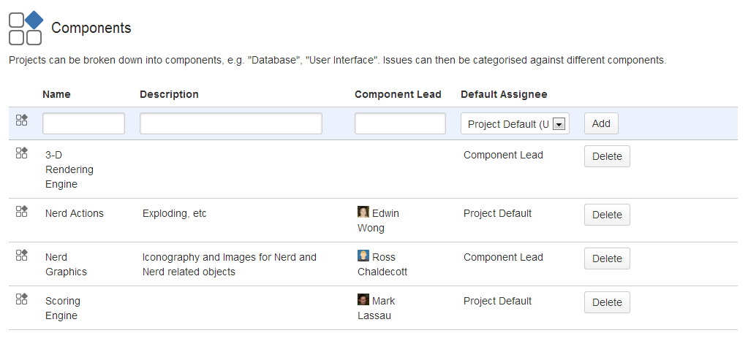

* Choose Settings > Projects > and tap the name of a project. The Project Summary page will appear.
* Choose Components in the left menu. The Components page is shown, demonstrating a rundown of Components and every Component's information.

##### 4. **Draw the different phase of workflows in JIRAtool.**

A JIRA workflow is an arrangement of statuses and transitions that an issue travels through amid its lifecycle and normally speaks to forms inside your organization. There are pre-defined built-in workflows that can't be altered; in any case, you can duplicate and utilize these built-in workflows to make your own.

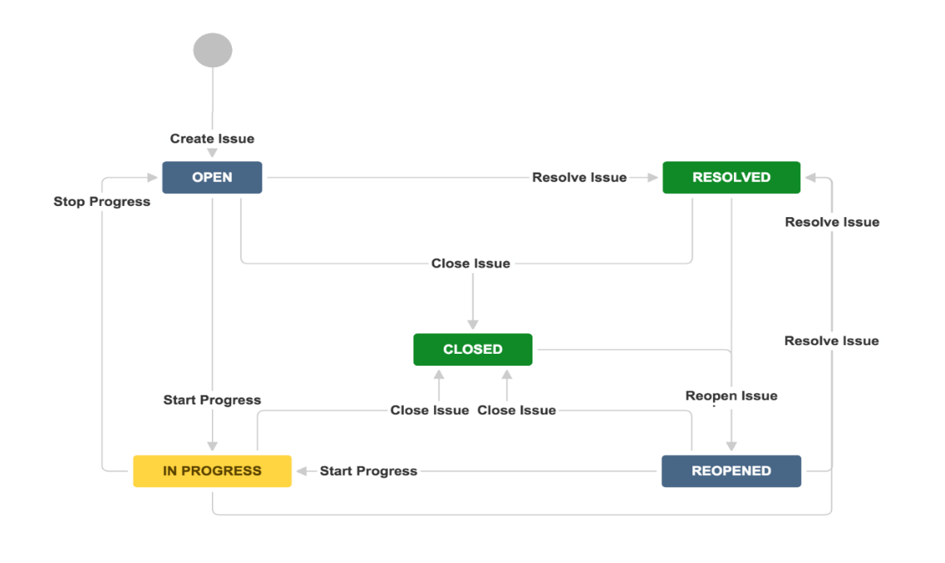

##### 5. **How a service desk works in JIRA tool?**

* Your client presents a demand for your service agents through an entryway or by means of email.
* A service desk sees the demand in their Jira Service Desk line and investigates the issue.
* Your client and different members utilize the entry or email to talk about the demand with your service desk agent, who works in the Jira Service Desk.
* Your specialist finishes the demand and your client is fulfilled!

6.Demonstrate the steps for creating User stories in JIRA are created in the JIRA Issues:

* You can have a product backlog by creating a main User story and having various sub-tasks under it.
* Or you can create an Issue type -Epic and Issue type – Story linked to it. To do so, in the ‘Create Issue’ page you can go to “Configure Fields” and choose the “Epic Link” field to be included in the issue creation screen. – This is the most commonly used method.

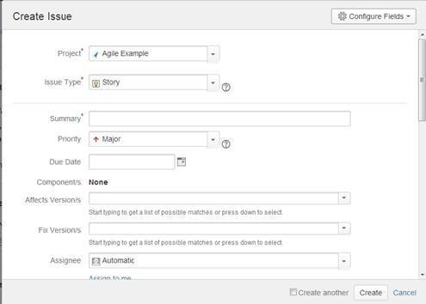

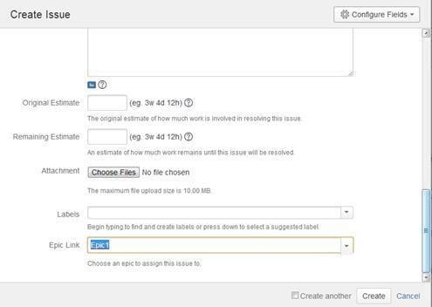

7. Demonstrate the steps to create a Plan Mode in jira tool.

The following is how the Planning mode looks like:

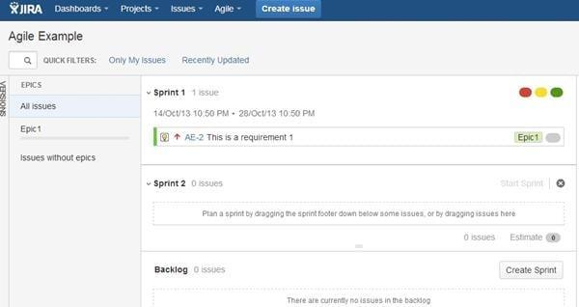

* The Planning mode displays all the user stories created for the project.
* You can use the LHS menu to decide the basis on which the issues need to be displayed. You can choose to view all the issues or only the ones related to a certain Epic.
* Change the order in which issues need to be considered simply by dragging them up or down in the backlog.
* From the RHS side menu upon clicking on an issue, you can create links, subtasks, legwork and perform any other activity like you would on a normal issue.
* You can use this screen to create a sprint too if you have the right permissions.

8.Demonstrate the steps for checking in Managing Boards in the tool

With the right permissions or if you are an admin, you will be able to configure a Board after its creation. To do so, go to “Agile->Manage Boards”. In the following screen, select the “Configure” option next to the board that you want to edit from the list of all boards available. *(Click on image to enlarge)*

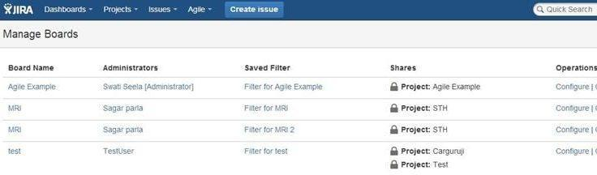

From the following page that comes up you will be able to define/edit the details as needed:

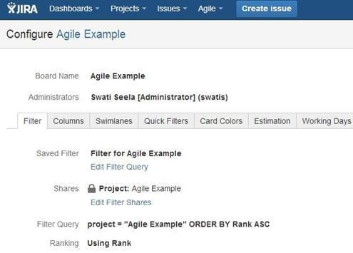

9.Demonstrate the steps to edit multiple issues at the same time in the jira tool.

Editing multiple issues at the same time can be done by performing a bulk operation. To perform this bulk operation, you will need the global Make bulk changes permission and the relevant permission for each project.

Bulk operations available in JIRA are as follows**

* Transition multiple issues through a workflow
* Delete multiple issues
* Move multiple issues
* Edit multiple issues
* Watch or stop watching multiple issues

10. **What elements are included under the change history for any particular issue in the tool ?**  
Change history for any particular issue includes the following

* Creation and deletion of a comment
* Creation and deletion of an issue link
* Deletion of worklog
* Attachment of a file
* Issue field changes